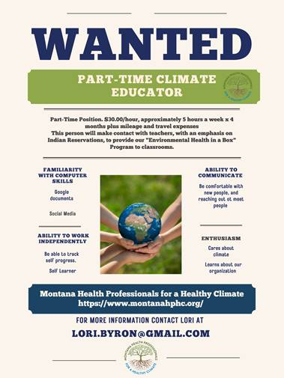

Wanted : Part Time Position. $30.00/hour, approximately 5 hours a week x 4 months plus mileage and travel expenses
This person will make contact with teachers, with an emphasis on Indian Reservations, to provide the "Environmental Health in a Box" Program to classrooms.
Requirements:
Familiarity with computer skills, Google documents.
Ability to work independently and track progress.
Ability to communicate with new people.
Enthusiasm

