**BOBCAT LESSON PLATE TEMPLATE**

***(Aligned with the Danielson Framework for Teaching and the New InTASC Standards)***

|  |  |  |  |  |
| --- | --- | --- | --- | --- |
| **Name:** | | | | |
| **Class:**  Animal Science | | | **Date:**  9/08/2022 | |
| **Unit or Sequence Topic:**  Into to Beef Production | | | **Lesson Title:**  Beef Cattle Digestive System | |
| **RELATIONSHIP TO SEQUENCE**  *(InTASC #5: Application of Content; Danielson 1e: Designing Coherent Instruction: Lesson and unit structure)* | | | | |
| **Sequence relationship:**  This is lesson #3 of Beef Production. Tuesday, we went over Beef Cattle Management. We talked about production systems, handling, equipment, health, nutrition, selection, calf management and environmental management. Students were given guided notes to following along with. At the end of the lesson they turned those in and that’s how I measured if students were ready to move on. Wednesday went covered Beef Cattle Digestive System. Went over the 4 different stomachs and what their jobs are. Next, I split them into groups of 3-4 students, each group was assigned a stomach, they create any kind of presentation that they would like. This lesson will lead/prepare students for a deeper dive into nutrition and feed.  Today’s lesson, we will review each of the stomachs with a kahoot game, students will present their presentation and then we will play a game called “Guess That Stomach” | | | | |
| **CONTENT**  *(InTASC #4: Content Knowledge; Danielson 1a: Demonstrating Knowledge of Content and Pedagogy)* | | | | |
| **Standards addressed:**  **AS.06.03.**  **Select and train animals for specific purposes and maximum performance based on**  **anatomy and physiology.**  **AS.06.02.**  **Apply principles of comparative anatomy and physiology to uses within various**  **animal systems.** | | | | |
| **INSTRUCTIONAL OUTCOMES**  *(InTASC #7: Planning for Instruction; Framework Domain 1c: Setting Instructional Outcomes)* | | | | |
| Students will learn….what the ruminant digestive tract/system workseach stomach’s jobtypes of diseaseswhat each stomach looks/feels like  * each stomachs name * the order of the stomachs and what they lead to next....small intestines, cecum, large intestines… | | | | |
| **…so…** | | | | |
| **…they will be able to…[Bloom’s verb]**   * Students will be able to identify the different parts of the ruminant digestive tract. * Students will be able to identify the different functions of the ruminant digestive tract. * Students will identify and explain how nutrition can affect the body more than just the digestive health. * Students will be able to identify a stomach chamber based on what they can feel with their hands…(Guess that Stomach chamber) | | | | |
| **Differentiation Strategies**  *(InTASC #2: Learning Differences; Framework Domain 1b: Demonstrating Knowledge of Students)* | | | | |
| **What?** | | **Where?** | | **Why?** |
| **Level II** | **Level III** |
| Accommodation: there will written instructions and I will verbally describe them. There will be picture along with any definitions. |  | Most students should be able to participate in this activity with help from group members, they will be put into groups to make the activity run slightly smoother and faster. | | In this class, no differentiation should be needed. Not every person in class has to speak and not every person is going to have to speak during the presentation. |
| If needed, I will walk the students who need it through the game and worksheet. |  | Differentiation shouldn’t be needed for the game either, if students do not want to use their bare hands, I will provide gloves. | |  |

|  |  |  |  |  |  |
| --- | --- | --- | --- | --- | --- |
| |  | | --- | | **ASSESSMENT**  *(InTASC #6: Assessment; Framework Domain 1f: Designing Student Assessments)* | | **Assessment (Formative):**  **Wednesday**  A majority of the students in this class will already have a good understanding of the digestive system but for those that do not know or completely understand we will go through each stomach, each one’s role and why they are important to the system.  Students will be given a worksheet to fill in as I go through the power point, they will turn this in at the end of class so that I can see who is ready and who is not ready to move on.  Once I have gone through the power point, students will be broken into groups of 2-3 students, each assigned a part of the digestive system, they will create a presentation and present on Thursday. Students can make a poster, power point, drawings or something else that is creative. Each group will need to research their stomach and know the function, location and action of their stomach. I will also use this to measure readiness.  **Thursday**  Each group will present their presentation, each student will be graded on participation and which part of the presentation they research and prepared.  “Guess that Stomach” game, each student will stick their hand all 4 buckets and write down which stomach they think each one is on a provided worksheet. They can put their hand in each bucket as many times as they need to, once they think they have each one correct, they will turn in worksheet and then I will tell them which one is which. | | Individual proficiency measure: I will measure individual proficiency based on the worksheet from Wednesday lesson, individual group participation and research, kahoot game and by their “Guess that Stomach” worksheet. | | Readiness of class to move forward: I will know the class is ready to move on based on our review kahoot game/in class discussion, each groups presentation and how well the class does at figuring out “guess that stomach” | | Remediation plan for those not proficient: For those that are not ready, struggling or missed class, they can come in on Friday and we will go over the stomachs together, go over their worksheet from Wednesday and replay “guess that stomach”. | |
|  |

|  |
| --- |
| **MANAGEMENT**  *(InTASC #3: Learning Environments; Framework Domain 2D: Managing Student Behavior)* |
| **Lesson-specific Targeted Management Strategies**  Management for Wednesday lesson will be pretty simple since it will be mostly lecture. To keep students engaged, they will have a worksheet to follow along with and fill out as I go through the power point. For the second half of the lesson, I will break students up into groups of 2-3 students, assign each group a part of the digestive system and provide materials if they would like to make a poster. As groups are working on research and creating their presentation, I will be walking around and talking with each group to make sure they are staying on task.  Management for today’s lesson at the beginning should be simple as they are presenting, just keeping students respectful and quite as each group presents.  During “Guess that Stomach” I will need to tell them the rules before they begin, to keep their guesses to themselves and monitor them as they are putting their hand in each bucket. |

|  |  |
| --- | --- |
| **METHODS AND INSTRUCTIONAL STRATEGIES**   |  | | --- | | *(InTASC #8: Instructional Strategies; Danielson Framework Domain 1e: Designing Coherent Instruction)* | |
| **Introduction, AKA: Anticipatory Set or Focusing event (Time Stamp): 10-15 minutes**  To start todays lesson we will play a Kahoot game to review what we went over in Wednesday’s lesson. The Kahoot will have 10-15 questions, some will be true or false others will be multiple choice. |
| **Instructional Strategies/Activities (Time stamp each segment): 35 minutes**  Each group will present their assigned part of the digestive system and have 3-5 minutes to present about its function, location and action. We will present in order of the digestion process. Once all groups have presented, we will move on to “guess that stomach”. I will tell them the rules before they get going and hand out their worksheet as I tell them the rules. They are to line up single file, each dip their hand in each bucket, feel around, be respectful, don’t squeeze to hard and break what’s in each bucket, and keep quiet and their guesses to themselves. Students can go up as many times as they need to make their guesses. |
| **Wrap Up/Synthesis/Closure (Time stamp): 10 minutes**  Once everyone has made their guesses and has them written down, they will turn in their worksheet and I will tell them which stomach is which.  To wrap up, I will remind them to turn in any missing assignments and what we will be moving on to next. |

|  |
| --- |
| **MATERIALS/RESOURCES**  *(InTASC # 7: Planning for Instruction; Danielson Framework Domain 1d: Demonstrating Knowledge of Resources)* |
| **Instructional Materials/Resources:**  - Power Point  - “Guess that Stomach” Hand out  - 4 Buckets  - Carpet, Waffle, Innertube, Plastic Bag with Crisco in it  - Warm Water  - Gloves |

**Name:**

**Ruminant Digestive Systems Notes**

**Ruminant Digestive Systems**

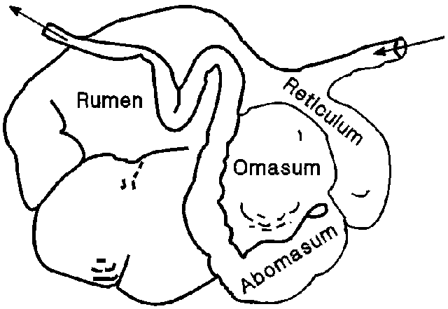

**Rumen:**

**Reticulum:**

**Omasum:**

**Abomasum:**

Name:

Guess That Stomach

|  |  |
| --- | --- |
| “Stomach” #1 | “Stomach” #2 |
| “Stomach” #3 | “Stomach” #4 |