Plant Science Unit 

Pest Identification

Pest Control

Pest Management Practices

**Pest Identification**

**Plant Pests**: Any living thing that can cause direct or indirect injury, damage or disease in any plant

**Identifying Characteristics of Pests**

* Structure of mouthparts
* Wings
* Legs
* Antennae
* Physical damage to plants
* Evidence of nesting
* Body colors

**Aphids**

Aphids attack many types of crops all across the world and largely effect the corn crops. They sucks sap from plants and deposits a sticky substance called "honeydew."

**Identifying Characteristics**

* Pear shaped bodies
* Variation in color: white, black, brown, gray, yellow, light green, or even pink!
* Smooth or wooly coating
* Long antennae
* Some adults can have wings

**White Grub**

White Grubs also effect corn crops and many others, including your own backyard! White Grubs start out as larvae and transform into adult beetles. White Grubs chew off the grass roots just below the soil surface.

**Identifying Characteristics**

* Typically 1 inch long
* Soft/plump
* Gray-white bodies with brown heads
* 6 distinct legs
* When disturbed: curl into a C shape

**Army Worms**

Army Worms feed on wheat crops and many other forage grasses. They begin by feeding on the seedlings and once wheat crops begin to mature, army worms move up and eat away at wheat heads.

**Identifying Characteristics**

* Greenish brown with a narrow, mid-dorsal stripe
* Yellowish head
* White and orange stripes down their bodies
* Large, single dark spot at the base of each of the 4 of fleshy abdominal prologs

**Hessian Fly**

Hessian Flies are very destructive to wheat crops and many other cereal crops. Once they have transformed into adults they only live for about 3 days. Females lay their eggs in the grooves of wheat leaves. After hatching, they begin feeding on the lower part of wheat stems.

**Identifying Characteristics**

* Small black fly - smaller than a common mosquito
* Females have dull red abdomens
* Males have brown or black abdomens
* Bead-like antennae
* Black colored wings
* Legs as long or longer than their bodies

**Grasshopper**

Grasshoppers can cause serious damage to barley crops and most other plants. Females lay their eggs in the soil and hatch as nymphs that come to the surface in spring and early summer. Grasshoppers begin feeding on young barley plants and can cut the stem below the seed head.

**Identifying Characteristics**

* Long hind legs
* Wings- front set of wings are not used to fly
* Variety of different colors
* Females are larger than males
* Antenna length and placement vary between types of grasshoppers

**Cereal Leaf Beetle**

Cereal Leaf Beetles severely effect barley and most other grain crops. The Cereal Leaf Beetle is an imported pest from Europe. Their larvae cause the most damage by feeding on the surface of leaves. Cereal Leaf Beetles primarily feed on young barley plants.

**Identifying Characteristics**

* Bluish-black antenna, head, abdomen and wing-covers
* Legs and thorax are brown to light orange
* 6 legs
* “Linking” antenna

Pests Two Truths & A Lie

Within your groups, decide which statement is the lie. Once your group has decided, ring your buzzer!

**Aphids**

Their Legs can be longer than their bodies

Adult aphids can have wings

Aphids have pear shaped bodies

**White Grub**

White grubs are Soft and Plump

White grubsHave long antenna

White grubs have6 distinct legs

**Army Worm**

Army worms have yellowish heads

Army worms have 4 fleshy abdominal prologs

Army wormslargely affect Corn crops

**Hessian Fly**

Hessian flies arebigger than the common mosquito

Female hessian flies have dull red abdomens

Hessian flies have bead-like antennae

**Grasshopper**

Grasshoppers front set of wings are not used to fly

Grasshoppers lay their eggs on grooves of wheat leaves

Female grasshoppers are larger than males grasshoppers

**Cereal Leaf Beetle**

Cereal leaf beetles have 6 legs

Cereal leaf beetleslegs and thorax are brown to light orange

Cereal leaf beetlesprimarily feed on wheat

**Pest Control**

**Pest Control**: the regulation or management of a species defined as a pest.

**Types of Pest Control:**

| **Biological** | Natural method, efficiently reduces number of pests without affecting environment |
| --- | --- |
| **Mechanical** | Use of machines, tillage, rids crops of pest habitats |
| **Poisoned Bait** | Used for rodents |
| **Field Burning** | Field is burnt to rid of any existing harmful species |
| **Trap Cropping** | Planting crop to attract pests to it instead of the crop being used for production |
| **Pesticides** | Most common, liquid or dry chemicals mixed with water and other liquids that are then sprayed on crops |

**Benefits from Pest Control:**

* Produce more with less
* Helps to ensure a bountiful harvest
* Keeps food products affordable
* Can reduce the impact of waterborne and insect transmitted diseases
* Helps to conserve environment (less tillage and more use of chem-fallow practices)
* Creates a more secure environment for food/crop storage

**Damage from Pests:**

**Corn Leaf Aphids:**

* Found in U.S. and Canada
* Abundant in June-November
* Dry weather seems to favor an increase in numbers and results in plant damage
* Feed by sucking sap from the upper leaves and tassels. Infested tassels are then covered with a sticky substance called **honeydew** that drips onto the leaves and silks. Pollination can be affected by honeydew covered silks.
* After infestation, plants develop a black, sooty appearance from the fungus that develops and thrives on the honeydew excreted by the aphids.
* **Controlled by:** Pesticides and biological methods (environmental factors, several parasitic wasps, a fungal disease, lady beetles, syrphid fly larvae, and lacewing larvae and adults)
* **Scouting:** Corn plants are most frequently injured by the aphids during the late whorl or pollen shed stage. If 50%+ of plants are infested with colonies of 75+ aphids each, pesticide treatment is warranted.

**White Grubs in Corn:**

* Abundant April - September
* Damage typically appears as stunted, wilted, discolored, or dead seedlings and/or as gaps in rows where plants fail to emerge.
* White grubs prune roots and can feed on the mesocotyl causing plant death
* **Controlled by:** Pesticides and biological methods (cultural control techniques, such as crop rotation, weed control, mid-season plowing, and pasturing hogs on infested fields)
* **Scouting:** 2+ live white grubs per ft3 of soil prior to planting may signal a potential problem. Some soil insecticides are labeled for white grub control and may only be needed if grubs are actively feeding. No insecticides are recommended as rescue treatments.

**Armyworm in Wheat:**

* Abundant in spring
* Infestations usually develop first in very thick and lodged stands
* The name armyworm derives from its behavior of migrating in large numbers into fields similar to invading armies.
* Cool, wet, spring weather usually favors armyworm development.
* **Controlled by:** Pesticides, mechanical methods, and field burning
* **Scouting:** If the armyworms are longer than about 1-1/4 inch they have completed most of their feeding. Control actions in small grains are recommended when scouting finds on average 16 armyworms, between 1/2 and 3/4 inches in length, per 4 ft2

**Hessian Fly in Wheat:**

* Abundant after wheat breaks dormancy
* Females lay reddish-tinted eggs in the grooves on the upper side of wheat leaves. Young maggots hatch in 3-10 days and move down the stems behind the leaf sheaths. They get to the lower part of the stems and begin feeding. Maggots will stay in this area and never enter the stem, but they will cause the stem to break due to it being weak and the weight of a full head stresses on it.
* At two weeks, the maggot enters the flaxseed stage where they stay for several weeks and are unharmed due to being in the lower parts of the stem.
* **Controlled by:** Pesticides, mechanical methods, crop rotation by keeping new crops away from infested fields, field burning to rid of eggs present in stubble, and use of treated seeds
* **Scouting:** No economic thresholds have been established.

**Grasshoppers in Barley**

* Summer-fall
* Lay eggs in soil
* Cause damage by defoliation, as they consume and clip foliage as they feed and feed on ripening grain.
* Favorable, warm dry climates cause them to hatch and mature two to four weeks earlier than normal. Early hatching (early May) threatens establishment of crops planted in early spring.
* **Controlled by:** Pesticides, predators, environmental factors. Tillage and reduction in weedy or grassy areas around crops will help deter the insect. Crop rotation by keeping new crops away from infested fields, field burning to rid of eggs present in stubble, and use of treated seeds. Difficult to control because it is highly mobile.
* **Scouting:** Sweep net sampling to find the number of grasshoppers per yd2. 15+ is abundant, 3-7 is light, and 0-2 is non-economical.

**Cereal Leaf Beetle in Barley:**

* Most damage is likely to occur in irrigated fields in cooler, moister parts
* Wide range of host grasses, both in the larval and adult stages and prefers spring-seeded small grains beetles prefer young plants and younger growth on plants.
* Rarely found on broadleaf plants.
* Damage is caused by feeding on the leaves. Feeding can result in transparent slits in the leaf blade and heavy feeding can cause the entire leaf to turn white. Damage is especially noticeable during the flag leaf stage where an entire field can look “frosted”.
* Yields can be reduced by 30-50% if left untreated. Adults feed on leaves but rarely cause economic damage.
* Considered a quarantined insect throughout the United States, meaning the presence of beetles in grain restricts the exportation to uninfected counties or states. As a result, domestic grain markets require fumigation or guaranteed insect-free shipments to prevent the spread of beetles to new areas
* **Controlled by:** Pesticides and biological factors. Many parasitic insects will kill the beetle. Tillage of the fields reduce the effect of these parasites though. Cereal leaf beetle adults prefer to colonize thin, weak plants, so full stands and high-quality small grain will discourage migrating adults in the spring. Avoiding late planting in the spring because adults prefer younger growth. Early planted fields are not as attractive. Sometimes a heavy rain or irrigation can kill cereal leaf beetle larvae.
* **Scouting:** Walk through a field in a “W” or “N” pattern and check 10 plants in 5-10 different locations in the field. Record eggs and larvae present on plants and average per plant. Before the boot stage, 3 eggs or 3 larvae per plant requires treatment. After the boot stage, treatment is recommended for every 1 larva to flag leaf.

Identify and Control these Pests:

**Scenario 1:**

You’re working as a scout for a local crop consulting company for the summer. You start your job in late May and will mainly monitor corn fields. You have a coworker that helps you check the fields and you both started to notice gaps in where the crop is emerging in one field. Some of the plants around the gaps are wilted and/or stunted. You both start to dig into the row to see if there are seeds where the gap is. There are little white, chubby caterpillar looking bugs in the row and little to no remanence of seed there.

When you call your supervisor, he suggests monitoring how many are in the area to determine whether something should be done to help control the issue for the future. You start at one area and your coworker starts at the opposite end. You estimate the gaps to be 3 ft long and find 3 worms per row. Your coworker estimates to find only 1 per row.

**With information from the lesson, determine the insect and determine what control options there are.**

**Scenario 2:**

Your dad is a farmer and is paying you to help him monitor the crops to see what he may need to spray for. You begin checking the winter wheat fields that have started to emerge. When checking the field, you notice there’s more of the longer stems from stubble in one field. You start to check the emerging plants and notice there’s a strange looking fly around the plants. You make a note of this and move on.

A few weeks later, you check the same winter wheat fields. These fields have grown quite a bit and are starting to get taller. You check a few plants here and there and start to notice little red, egg-like things in the stems. There are more present in one field over the others. You make a note and ask your dad about it when you get back into the house. He decides to talk to a local pesticide representative to get a professional opinion.

The rep tells him to keep an eye on the crop. To determine if it is the pest the rep is thinking it is, you have to wait until the wheat heads start emerging. Late July comes and the fields have fully headed out. One field looks very thin compared to the others and you notice a lot of broken stems in this field. This seems alarming to you and you send photos to the pesticide representative.

**With information from the lesson, determine the insect and determine what control options there are.**

**Scenario 3:**

You have an interest in agronomy and keep an eye on the crops around your house. When you take your dog on a walk down the country road you live down, you look over the fields that are planted along the road. July is your favorite time of year to walk this path. You have noticed that the ditches along the road are full of really tall grasses. When you walk closely, you notice that there are many different winged bugs that are jumping all over the area. These bugs also jump into and out of the fields on the other side of the ditch. You notice many bite marks on the leaves of the grasses in the ditch and wonder if these bugs could be affecting the crops in the fields.

**With information from the lesson, determine the insect and determine what control options there are.**

Pest Management Practices

Integrated Pest Management is an ecosystem based strategy that focuses on long term management of pests and the damage they inflict on the environment around them. These pests are controlled through many different measures including biological control, habitat manipulation, modifications of cultural practices, and by the use of certain varieties that are resistant to pests. This program tries to limit the use of pesticides as they are only used when the monitoring of pests indicates pesticides are needed, and they are used very specifically to make sure that only the targeted pest is influenced. Overall, this program works to control pests in an efficient manner that poses little to no risk to humans, the environment, and organisms that are not being targeted.

**Setting Action Thresholds**

Before initially taking any action to control pests, the IPM program sets a precedent at which pest population as well as environmental factors suggest that action must be taken in order to control an infestation. This is very important as just the sight of a pest doesn’t necessarily require action. You must continuously monitor the situation and determine the point at which pests will become an economical threat to you as a producer and this is essential when making decisions regarding pest control.

**Monitoring and Identifying Pests**

Not all pests require control, and some can even be beneficial to your operation. Integrated Pest Management programs work to correctly identify and monitor pests so proper control resolutions can be made that correlate with determining when action to control an infestation must take place. This allows you as a producer to implement the proper management technique and prevents you from using pesticide when control isn’t needed as well as an improper type of pesticide.

**Insects beneficial to Agriculture:**

**Assassin Bug**

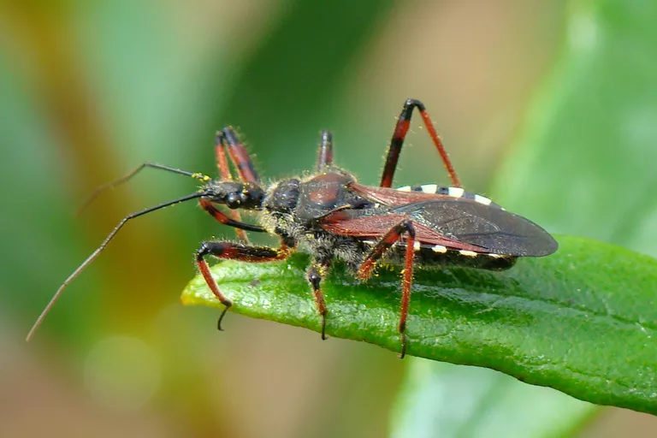

**Earwig**

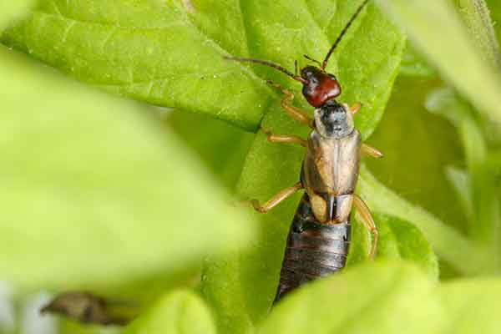

**Lacewing**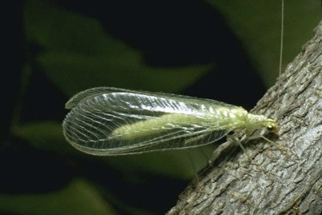

**Prevention**

Integrated Pest Management programs are largely based upon prevention and taking small steps to keep an infestation from becoming a major issue once pests have been identified. In terms of agricultural practices, you can work to manage your pest problem by using cultural methods such as crop rotations, using certain pest free varieties, and planting rootstock that is free of pests. The best part about these prevention methods is that they are usually very effective, inexpensive, and pose a very small risk to people as well as the environment.

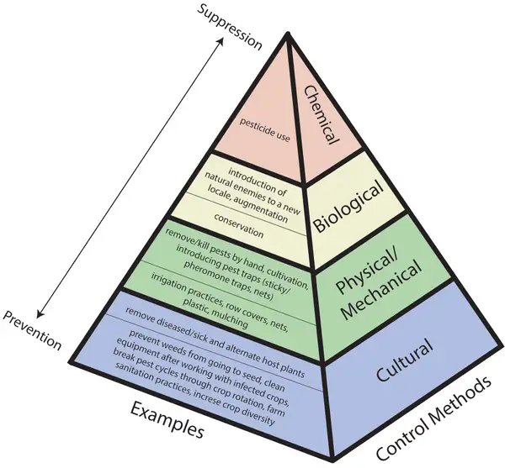

**Control**

As soon as it becomes evident that pest control measures are required, and preventive methods are no longer effective or available, IPM programs then begin to thoroughly evaluate the situation and determine the correct control method regarding the situation at hand. These management plans begin with less risky management techniques such as highly targeted chemicals used to disrupt mating of pests or even mechanical measures such as trapping. If these less risky management programs prove to be ineffective, additional methods such as targeted spraying of pesticides may be implemented. Broad-cast spraying of non-specific pesticides would be used as a last resort.

**Management Techniques**

| Broadcast Spraying of Pesticides | Tillage | Crop Rotation | Biological Methods |
| --- | --- | --- | --- |
| Weed Control | Targeted Chemical Use | Natural Predators | Mulching |
| Trap Cropping | Field Burning | Mowing | Irrigation Techniques |
| Introducing New Natural Enemies | Killing pests by hand | Sticky Traps | Barriers |