Explanation of new MSU Per Diem Rates (v3, August 11, 2025)

Effective July 1, 2025, the Montana Legislature changed the way per diem rates are calculated. The new rates are tied to the GSA standard rate and vary by location. Incidentals are not included in the calculation.

- In State Travel: $44.10
- Out of State Travel (to include AK/HI): $63.00
- International: 80% of GSA M&IE for a specific City/Country. (M&IE rates can be found at aoprals.state.gov/web920/per_diem.asp?PrintView=1)

Current US GSA Standard Rate = $68 (https://www.gsa.gov/travel/plan-book/per-diem-rates)
US Incidentals: $5
- In State travel is 70% of the GSA Standard Rate. Does not include incidentals. ($68 - $5 x 70% = $44.10)
- Out of State is 100% of GSA Standard Rate. Does not include incidentals. ($68 - $5 = $63). US Location does not matter.
- International is 80% of the M&IE rate and varies by city/country. Berlin, Germany M&IE rate is $140 so MSU per diem is $112 ($140 x 80%).

Note, there are about 300 “non-standard” locations that have higher rates, but Montana is simply using the Standard Rate.

International Per Diem by meal
International travel full day of meals = 80% of M&IE rate for location
International breakfast = 15% of M&IE rate for location
International lunch = 25% of M&IE rate for location
International dinner = 40% of M&IE rate for location

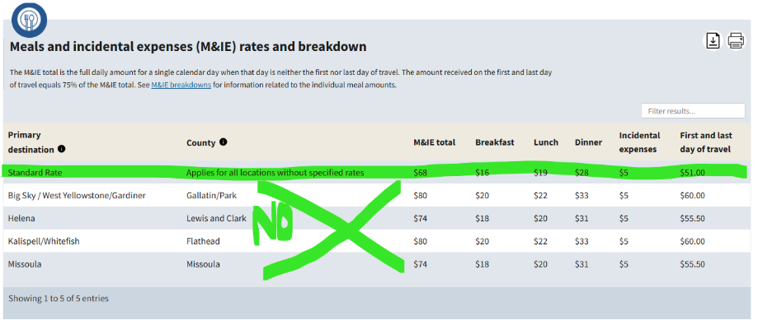
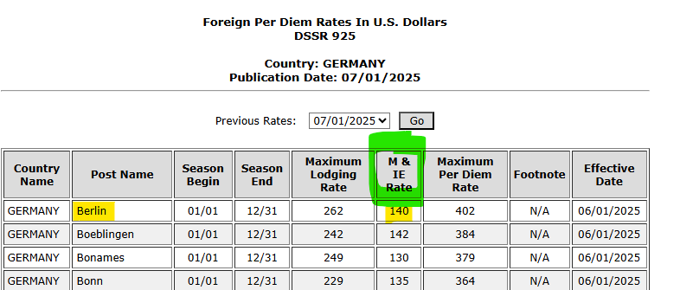

In Chrome River, users will need to enter the location of their travel in both pre-approval and expense reports. Chrome River will use this to determine the per diem rates. It is alittle slow when they type the location, so patience is key.

Pre-Approval
In both the Per Diem Wizard and Per Diem (Single Day), you type the city in the “Location” area. Then pick your city/state or city/country you are going to.
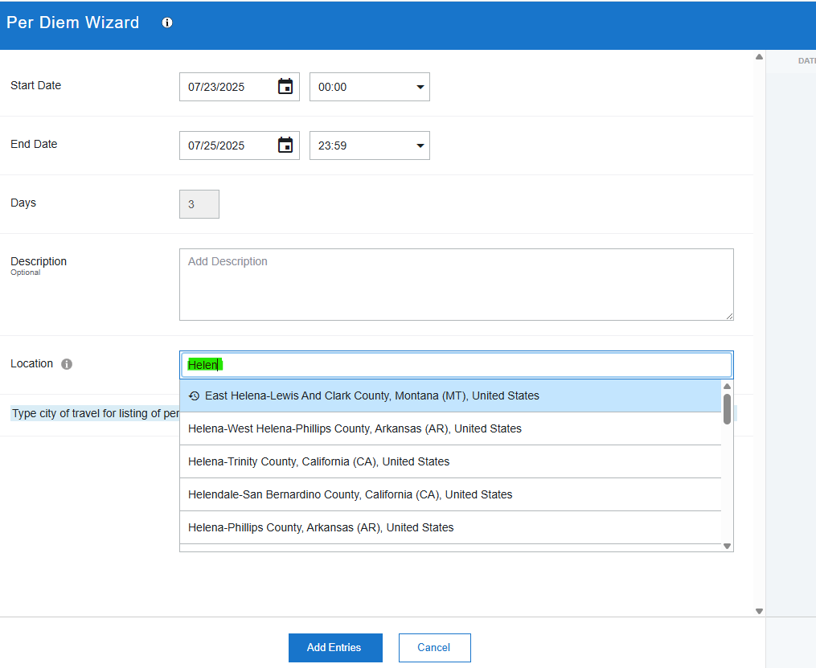
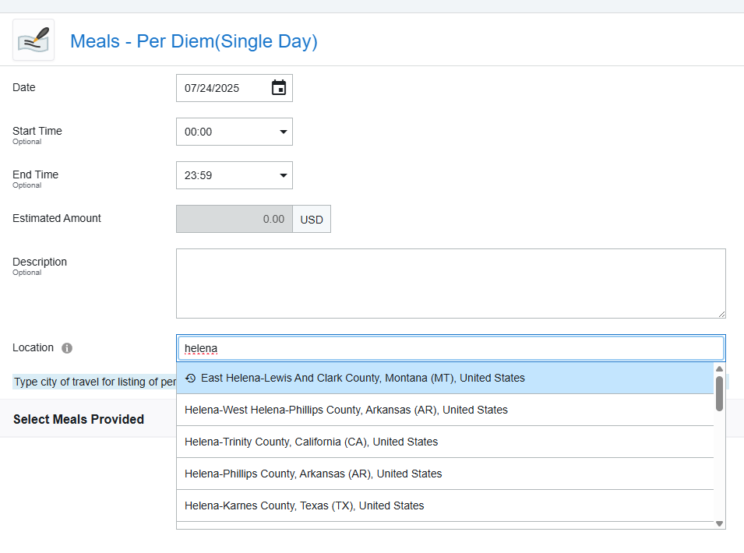

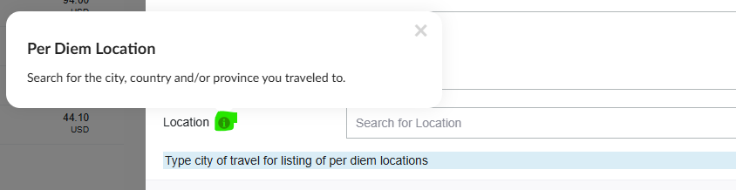

If you type “e” nothing will happen.
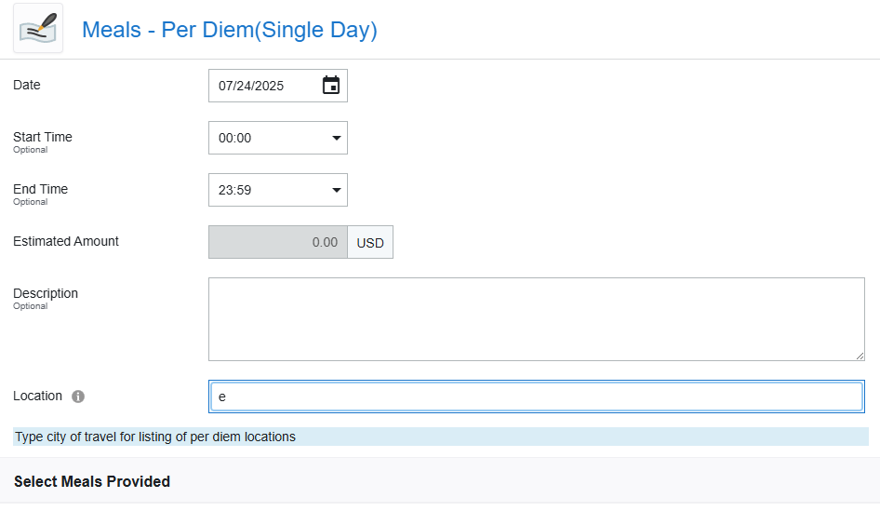

Expense Report
In the Per Diem (Single Day) your city goes into the location field, and in the “meal code” field there is the option to pick in-state, etc.
